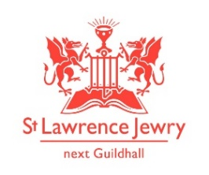

Bringing the Light of Christ to the City’
60th Anniversary
EVENTS
AUGUST 22ND at 1pm
CONCERT & RECEPTION
Josephine Goddard – Sopran0
and Sholto Kynoch – Piano

SEPTEMBER 16th/17th 10-5
OPEN HOUSE
Hourly talks on the history of
St Lawrence Jewry

OCTOBER 23rd 6pm
LAWRENCE LECTURE
Dr Kevin Rogers
‘Rebuilding the City Churches’

NOVEMBER
TBC

DECEMBER 20th 5.30pm
LORD MAYORS CAROL SERVICE
Followed by a wine and mince pies reception
2018
January
HIDDEN PLACES OF ST LAWRENCE JEWRY

February 14TH 5.30pM
VALENTINE’S DAY SERVICE
Come and renew your Wedding Vows,
before going out on your romantic date!!

MARCH
TBC

APRIL
PIANO/ORGAN CONCERT

MAY 23RD
WALKS & TALKS

JUNE
BEATING THE BOUNDS…IN A MINI!!

JULY
DEDICATION SERVICE FOR OUR NEW DOORS

St Lawrence Jewry Church, Guildhall Yard London EC2V 5AA
0207 600 9478
www.stlawrencejewry.org.uk

