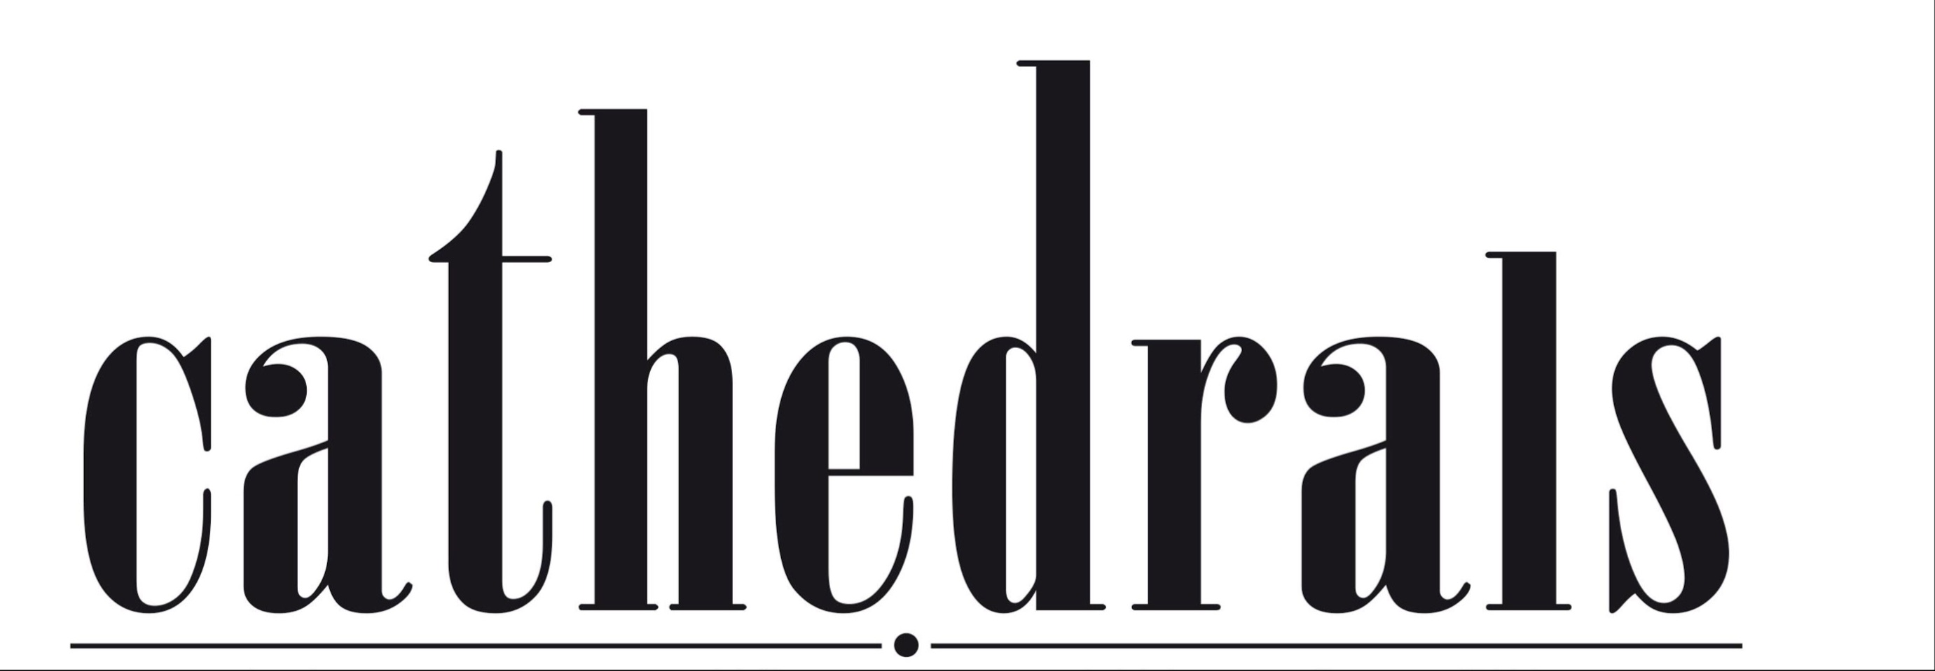

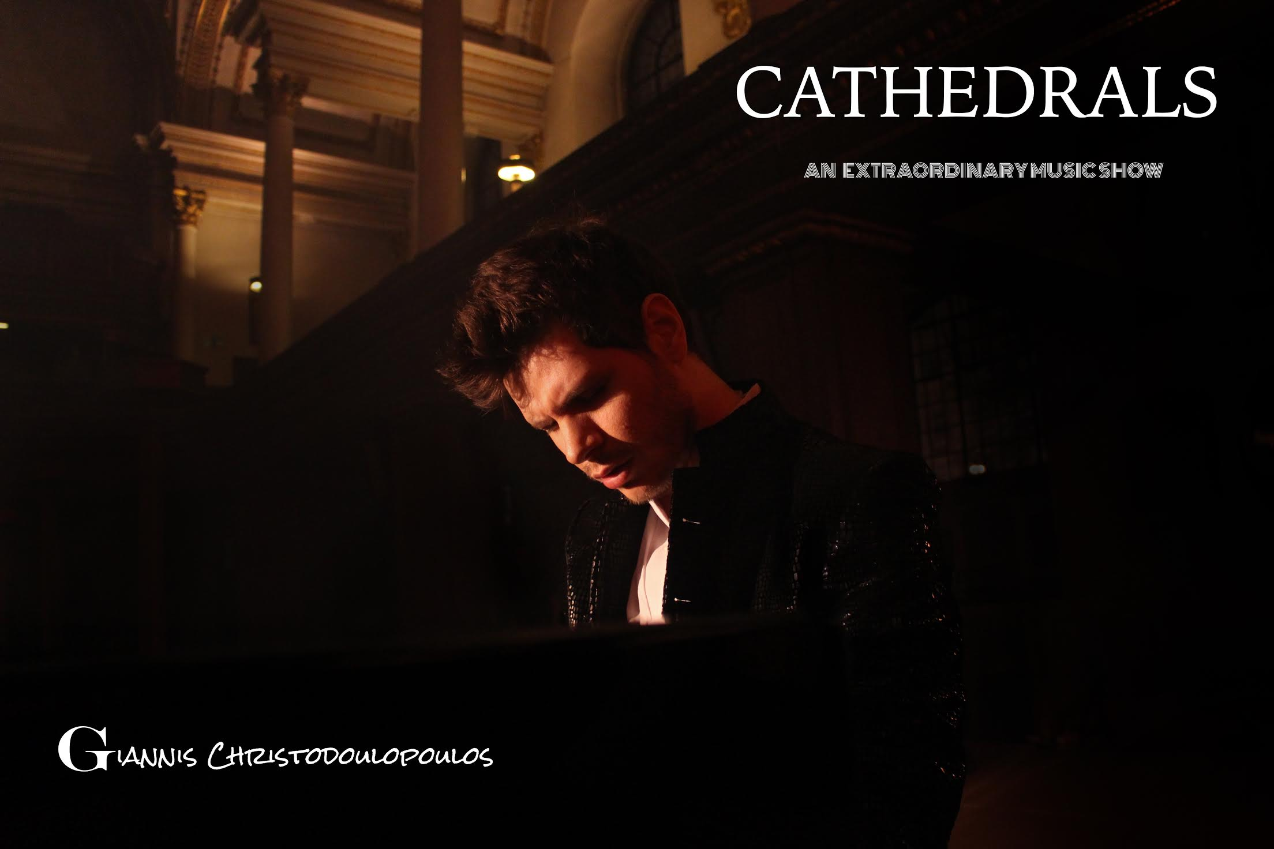
Ark4Art presents one of the most talented and popular young composers and performers, Giannis Christodoulopoulos, performing, composing and improvising in a unique musical show in London and St Lawrence Jewry, the official church of the Lord Mayor of London and of the City of London Corporation, with the participation of guest musicians and performers from around the world!

''The music is in all aspects of our lives.
in nature, in tears, in laughing even to our anger
Man generally avoids perceiving
sounds like music because it considers these vibrations given,
like life itself"

‘Combining classical music and jazz, his piano compositions show simplicity, great energy and the accessibility of powerful film music. He calls the show Cathedrals, for unexplained reasons, but when he was joined by the soprano Katerina Mina, I began to get an inkling of what may have been behind it. Singing from the pulpit, her crystal-clear voice exploited the acoustic of St James’s perfectly, soaring through the building, down the aisles and up to the high ceiling. The church may not be a cathedral but the singing was heavenly. Giannis ended with a highly unusual piece of audience involvement when he improvised compositions suggested by words they offered to indicate their emotions from melancholy to madness. This has certainly been a good period for non-celebrity unknowns.’
The Daily Express – William Hartston

In a time when communication is diffused in every direction, Giannis Christodoulopoulos brings the creator and the audience even closer, taking them to the heart of music. The most appropriate environment to conduct such an association between the audience and the creator is a place that requires this kind of ritual. A Cathedral is a place of thought and pray, a way to see and understand our inner-self. This show will motivate people of all cultures and different backgrounds to feel, take a minute to express their emotions and realize that we all have the same instincts, fears, moments of happiness and loneliness. Moments when all of us need to be together, understand and help each other, being equal, united, together.

The innovative Cathedrals show consists of two parts:

In the first part, Giannis Christodoulopoulos will be performing live his film compositions, themes for piano, improvisations, as well as transcriptions of classical masterpieces by great orchestra works only for a piano. In the second part of the show, the composer and performer will be trying something really innovative, by improvising and composing music in front of the audience based on the audience’s feelings.

Giannis Christodoulopoulos is a solo pianist, composer, singer and conductor. He was chosen to compose the theme for the Olympic Games in Athens 2004 and has a career in composing and cooperating with famous artists and composers. He has given a iconic concert for Action Trust Organisation in Royal Opera House in London, conducted the Billy Elliot orchestra in Greece and composed a charity piece dedicated to immigrants, performed in different charities and events.

More information about the artist at www.giannischristodoulopoulos.com
Presented by Ark4Art.
Produced by Celdi Partners.

DOCUMENTARY: https://www.youtube.com/watch?v=Z6eJBIMLFBo

Tickets to be released on the 18th of September at www.ark4art.com

