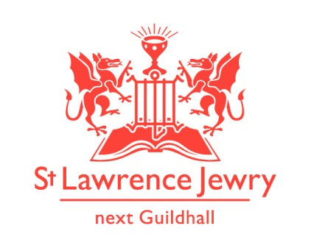
St Lawrence Jewry October 2013 Newsletter
St Lawrence Jewry is the church on Guildhall Yard, dedicated to bringing
the light of Christ to the City of London.

Dear Friends,

“The Lord will indeed give what is good, and our land will yield its harvest.”
Psalm 85:11-13 September was so packed with events that we had over 5,000 people though our church door. Let us give thanks and praise to God for all His blessings!

London Ride+Stride 2013

We are pleased to announce that Anya & Joseph Sutton, who did the Ride+Stride sponsorship event for St Lawrence Jewry, have so far generated £310.00 (£382.50 including gift-aid). Deadline to receive donation is 31st October 2013. Those who would like to sponsor them could still drop into the church and speak to Arnel Sullano or send the donations to Anya and Joseph’s JustGiving webpage http://uk.virginmoneygiving.com/team/JosephandAnyaforStLawrence. Ride+Stride organisers will also give an additional £500 to the church that generated the most number of donations. So please keep your generous heart open to support this event.

Open House London 2013

We would like to thank everyone who helped us during this weekend. Special thanks to Lucy and Layemi, our Sixth-Form students, who untiringly helped us serve tea, coffee and biscuits to our more than 2,500 visitors; to David Tootill, Artistic Director of Southbank Mosaics, who gave a mosaics demonstration in the church on Sunday; to the Friends of City Churches who sent some of their church watchers to help us welcome our visitors, and to our very own Friends of St Lawrence Jewry, David and Jackie Sheffield, for travelling all the way from Rayleigh just to give us a helping hand. The harvest is plenty and labourers are few but we all managed to keep it under control and made it a success.

Lord Mayor’s Election Day Service

One of the great Civic events of the year, The Lord Mayor’s Election Day Service, which took place in our church on 30th September, was a big success. The election in the Guildhall was an even bigger success for they have elected Fiona Woolf as the next Lord Mayor. Congratulations Fiona! Our hearts and prayers are with you for the huge tasks you are about to take on.

Music

Our weekly Monday Piano and Tuesday Organ recitals continue with successful scholars from The Eric Thompson Charitable Trust for Organists and Organ Music dominating most of the organ recitals this month. Programmes are available in the church or visit our webpages Piano and Organ.

“Beat the Bounds” Sunday 13th October 2013

The Worshipful Company of World Traders is organising “Beat the Bounds”, a historic and unique motorcycle ride led by the Lord Mayor and Lady Mayoress, on Sunday 13th October from 11am to 1:30pm. The ride will start and end in the Guildhall Yard. Our church will be open from 10am to 4pm to welcome the bikers and spectators. We are looking for volunteers to help us serve tea, coffee and biscuits to our visitors. Please contact Arnel for details.

Friends of St Lawrence Jewry

Those who have not joined us as Friends of St Lawrence Jewry are encouraged to do so. Not only will you be helping our church to generate income for us to continue our mission of being the light to the City of London, but you will also enjoy the company of your fellow Friends in the various events we organise for them. Please contact Katrina for further details.

Weddings/Blessing

Love is constantly in the air especially inside our beautiful church. We have two weddings for this month:

Neil Mehrtens & Fenella Sale - 12th October 2:00pm
Edward Harris Hughes and Clare Allsop - 26th October 2:30pm

Advance Notice

7th November at 7pm - “The Magic Flute” – the first full opera to be presented in our church. Mozart's fantastic opera blends fairy-tale adventure and playful comedy to tell a tale of magic, power and love with music as enchanting and spectacular as the plot is mysterious. Sung in English with chamber orchestra; performed by Opera Project; and organised by The Worshipful Company of Girdlers. Tickets are £50 in aid of our church. For ticket enquiries, please contact Robin.neill@stjohnschambers.co.uk or PReeve@albion-ventures.co.uk or see Arnel Sullano in the office.

Friday 8th November at 6.00pm is the Lord Mayor’s Installation Service in our church. Please come and join us in praying for God’s blessings and guidance to Fiona Woolf, as she starts her role as the 686th Lord Mayor of the City of London.

God bless you all.

David Parrott
vicar@stlawrencejewry.org.uk

If you receive this newsletter but do not wish to stay on our list please let us know and we will remove you.

Katrina Bradley
katrina@stlawrencejewry.org.uk

Arnel Sullano
arnel@stlawrencejewry.org.uk

