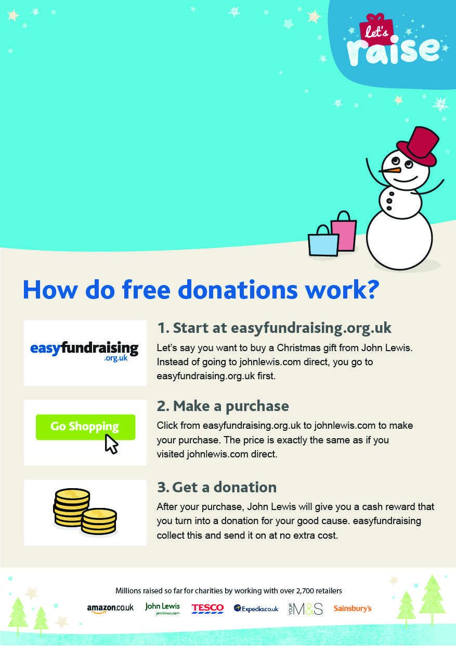­

**St Lawrence Jewry. Easyfundraising**

Help St Lawrence Jewry

raise free funds when

you shop online!

Please support us at:

**easyfundraising.org.uk**/**stlawrencejewry**