Restore, Décor & Remember

Help us raise fund to Restore the clock faces
in our tower by helping us Decorate our
Christmas tree with personalised Christmas
décor to Remember someone you love
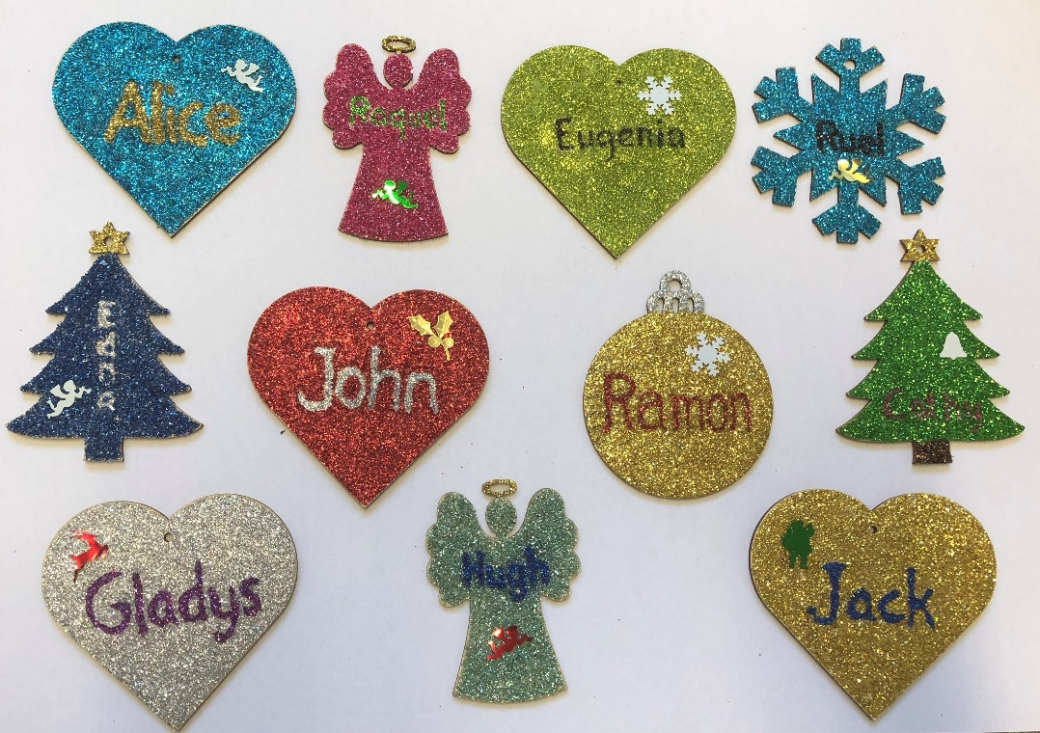

See overleaf for details

How does it work?

- For every £25 donation you will get a personalised Christmas Décor which will bear the name of the person you wish to be remembered for the month of December. This may be someone who has died, or your husband or wife or child, or any other name you would like to be remembered in this way.

- The Christmas décor will be used to decorate our Christmas tree this year.

- After Christmas, you can collect the Christmas décor as a memento.

You may donate your £25 at any time, but…

There is a chance to double your donation if you will donate
online through The Big Give Christmas Challenge website
between Tuesday 27th November and Tuesday 4th December.
Arnel will send you more details and a reminder near the time.

If you’re willing to help us in this fundraising activity then please
complete the form below and hand it over to Arnel in the office.

Amount of Donation: ____________ Date: _________________

Name of Donor: ____________________________________________

Name of Person(s) to be remembered: __________________________

__________________________________________________________

Pay by: Cash ___ Cheque ____ Card ____ Big Give ____

(Please give your email address to get details on how to donate via Big Give)

Email : ________________________________________________________

